MY PERIMETER AND AREA
PROJECT DUE: WEDNESDAY, APRIL 15, 2020
Students are to color in the squares to create a model of themselves. Once they finish their coloring, they can label the length of each side in units. Then they can use these measurements to find the perimeter and area.
This can be tedious, so please use a piece of scrap paper for calculations.
Work carefully and double check your work!
When you are done, please take a picture of the entire page and send to me via Classdojo messenger or by email: 302461@dadeschools.net.
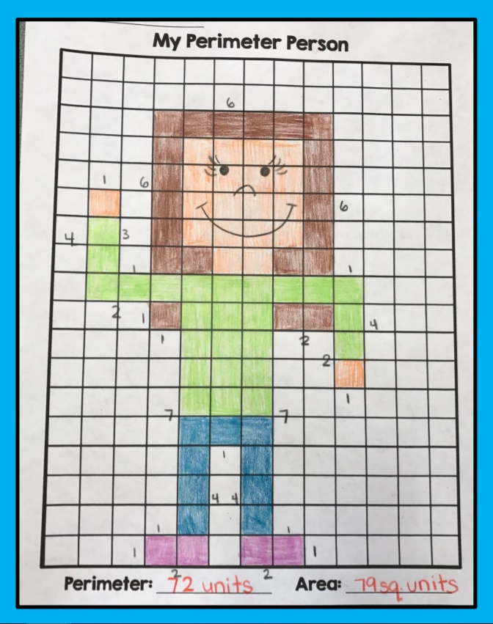
Example:

My Area: _________ square units
My Perimeter: _________ units
Student Name: _________________________________________

