EXTRA CREDIT EARTH DAY PROJECT!

Due: Thursday, April 23, 2020

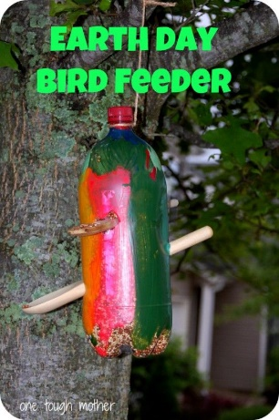
In honor of Earth Day, this week’s Extra Credit project will be for students to use recycled materials in order to make something that can be used while at home during this time.
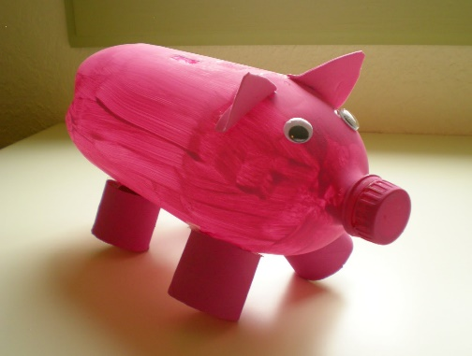
For example, they can use a plastic soda bottle to make a
piggy bank…

Or they can use it to make a bird feeder!

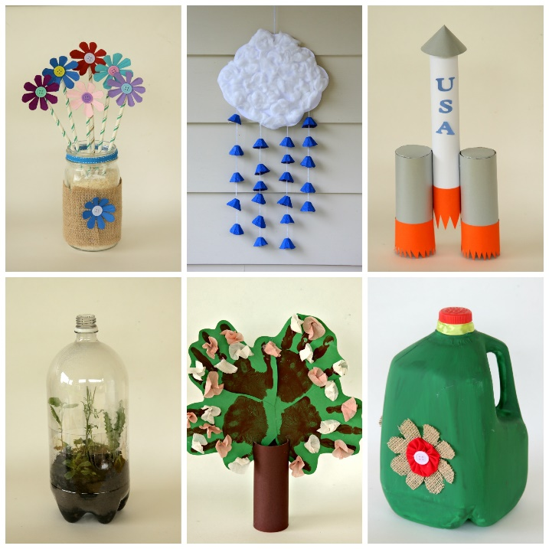
There are lots of creative ways to reuse, reduce, and recycle!
To get the EXTRA CREDIT “A”,
Students must:
- Make their project using recycled materials from home.
- Take a photo of themselves holding the final project.
- Answer the questions on the “project info worksheet”
- Send photo and completed worksheet to me on ClassDojo.
This project is OPTIONAL – It is NOT REQUIRED!
EARTH DAY Project Info Worksheet

- What materials did you use to make your project? ____________________________________________________________________________________________________________________________________________________
- What did you make with the materials? ____________________________________________________________________________________________________________________________________________________
- How is the project you made useful? _________________________________________________________________________________________________________________________________________________________________________________________

